|  |
| --- |
| CHATBOT DEPLOYMENT USING IBM WATSON ASSISTANT |

|  |
| --- |
| PHASE – 3 (DEVELOPMENT PART-1) |

|  |
| --- |
| Submitted by : |

Kaviya J P

au422421106016

[jpkaviya2003@gmail.com](mailto:jpkaviya2003@gmail.com)

**Building a chatbot using Watson assistant in ibm cloud :**

1. **Create a Watson Assistant Service:**
   * Go to the IBM Cloud dashboard and click on the 'Create Resource' button.
   * Search for 'Watson Assistant' and select the service from the list.
   * Give your service a name and click on the 'Create' button.

# Design the chatbot's persona and conversation flow:

# 

* + The chatbot we are going to create is a faq chatbot for the popular messaging platforms like facebook.
  + Give the name to your chatbot – FAQ chatbot
  + Choose an avatar or logo that represents the chatbot.
  + Plan the conversation flow, considering common faq questions asked by the users of facebook and the appropriate responses to the questions.

# Build the chatbot using IBM Cloud Watson Assistant:

* + Navigate to your Watson Assistant service and click on the 'Launch Watson Assistant' button.
  + Click on the 'Create' button and select 'Dialog skill' as the skill type.
  + Give the skill a name and description, and click on the 'Create' button.

# Define intents, entities, and dialog nodes:

* + Intents:

Identify the types of questions or requests your users might have. For example, 'how to recover the old password', 'how to reset a new password', 'how to post an image in facebook', etc.

* + Entities:

Recognize and extract specific information from user inputs. For example, 'password', 'recover', 'post', etc.

* + Dialog nodes:

Design the chatbot's response flow, using conditional logic and variables to customize the chatbot's response.

# Train your chatbot:

* + To improve your chatbot's accuracy and performance, provide it with a set of example questions and responses.
  + Train your chatbot using this training data and monitor its progress.

# Test your chatbot:

Use the 'Try it now' feature in Watson Assistant to simulate user interactions with the chatbot. Evaluate the chatbot's performance and make any necessary adjustments to improve its accuracy and user experience.

|  |
| --- |
| Steps involved in building the chatbot : |

1.Login to the ibm cloud services and click on the catalog and click on ibm Watson service .

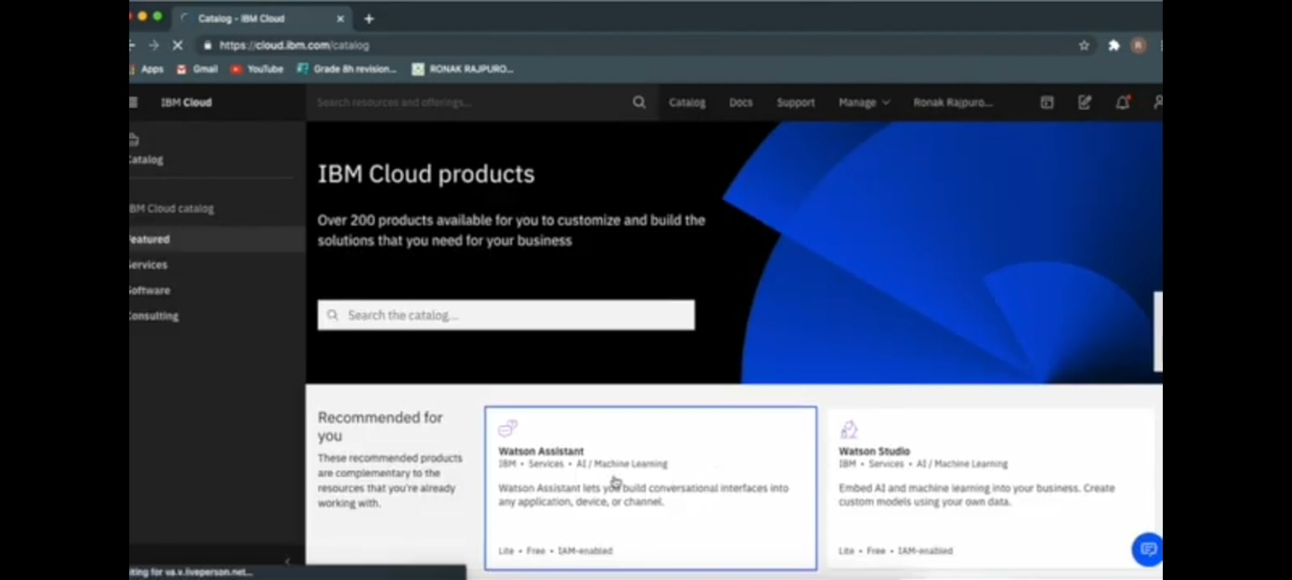

2.Select a region and select the resource group.

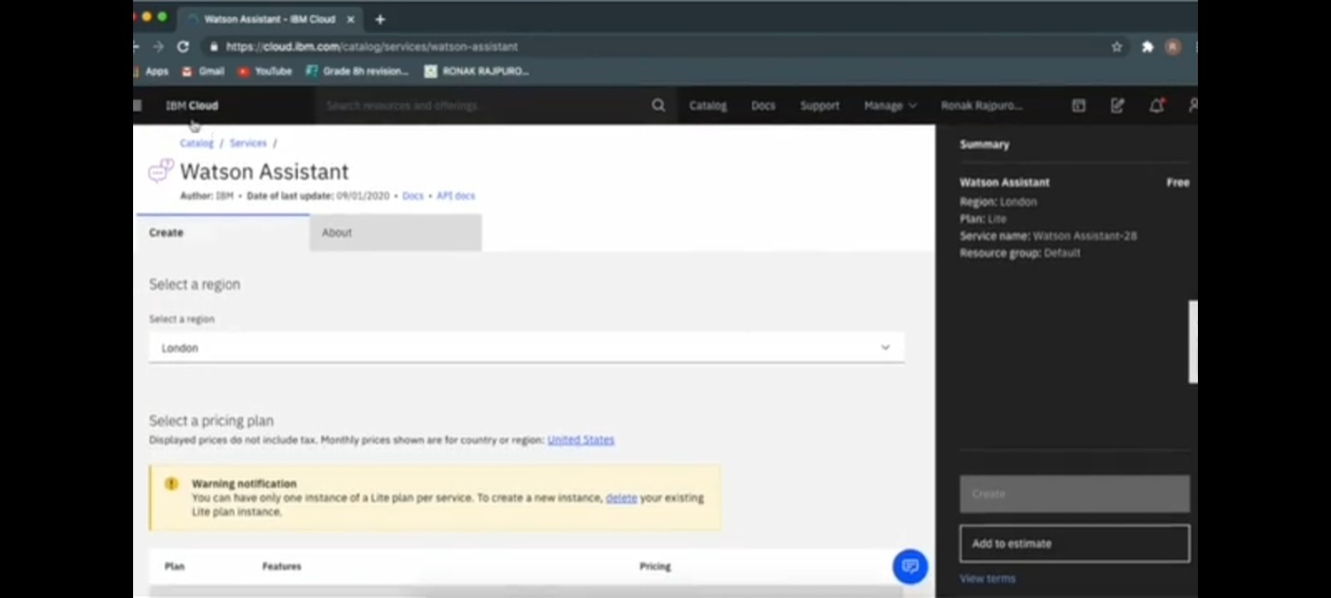

3.click on the resource list and click on the services dropdown menu. Click on the created Watson assistant service.

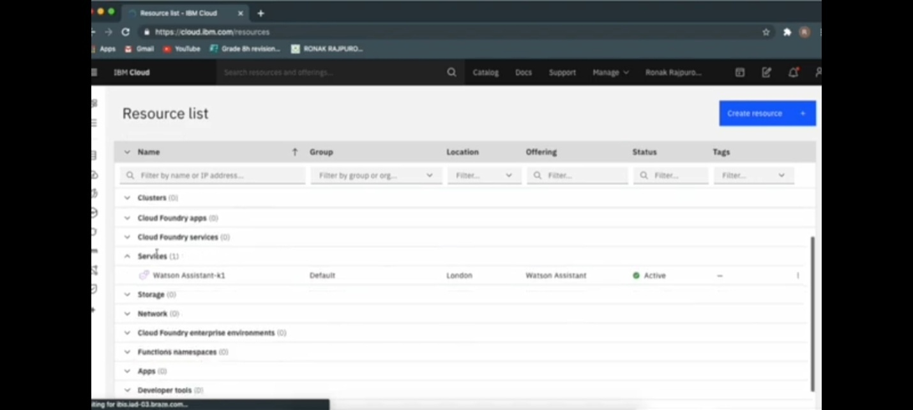

4.After clicking the Watson assistant service click on launch Watson assistant.

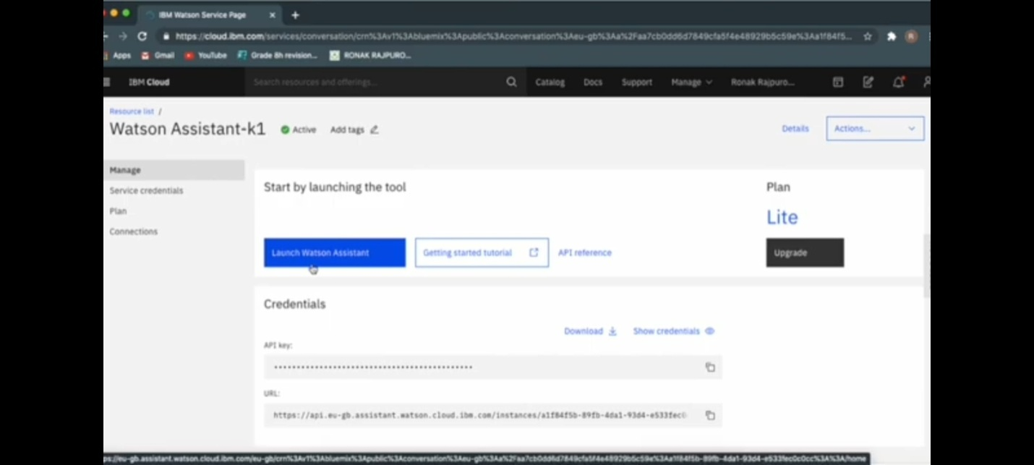

5.Create assistant window opens , give a name to the assistant ex:faq chatbot and add description if needed and enable the preview link for integrating it with messaging platforms.

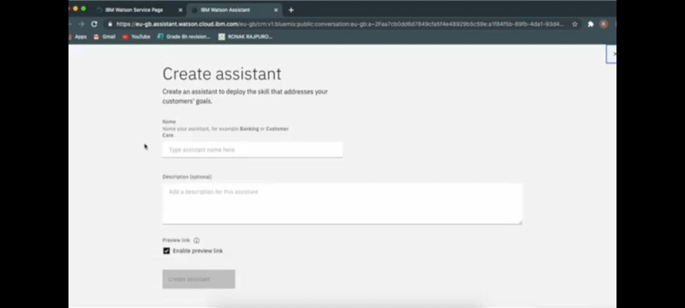

6.Add the dialog skill upto three or four skills as needed .

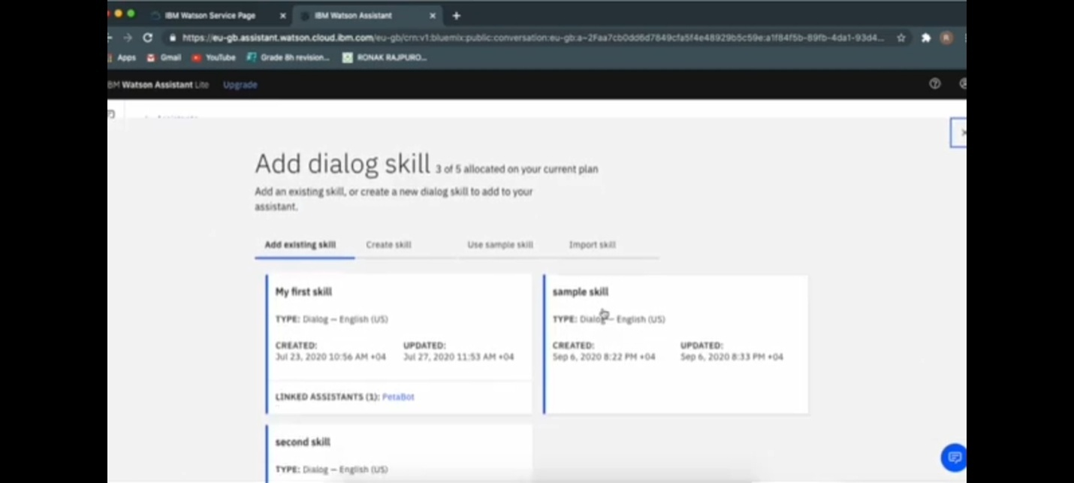

7.Add the intents for training the assistant by giving the user statements and answers.

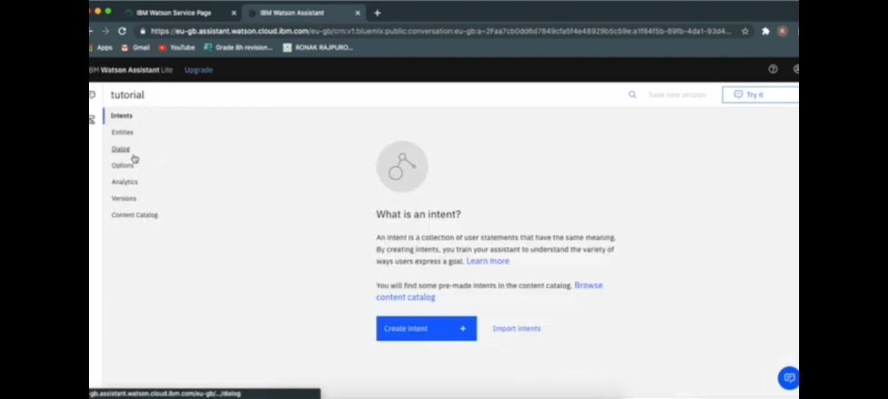

8.create the intent by giving them names example : greetings which includes giving greetings to the users.

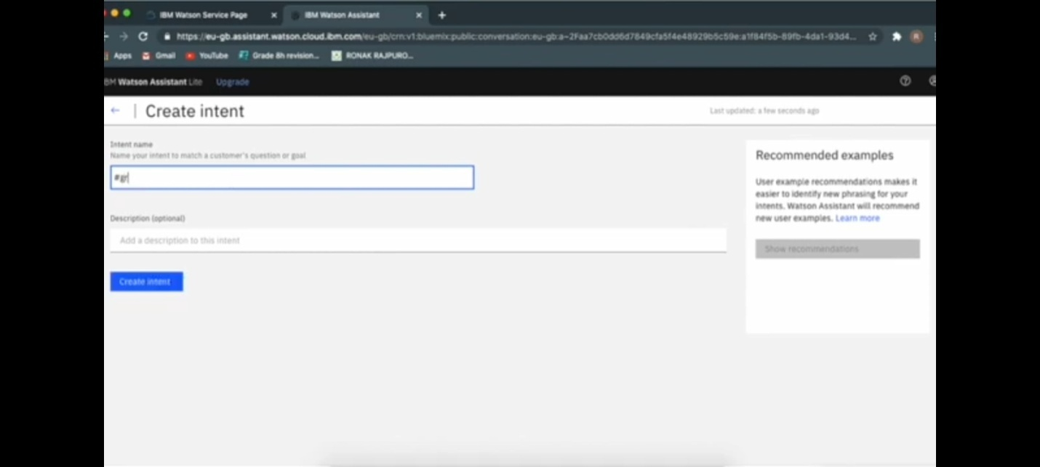

9.After creating the intents tutorial window opens consisting of added intents.

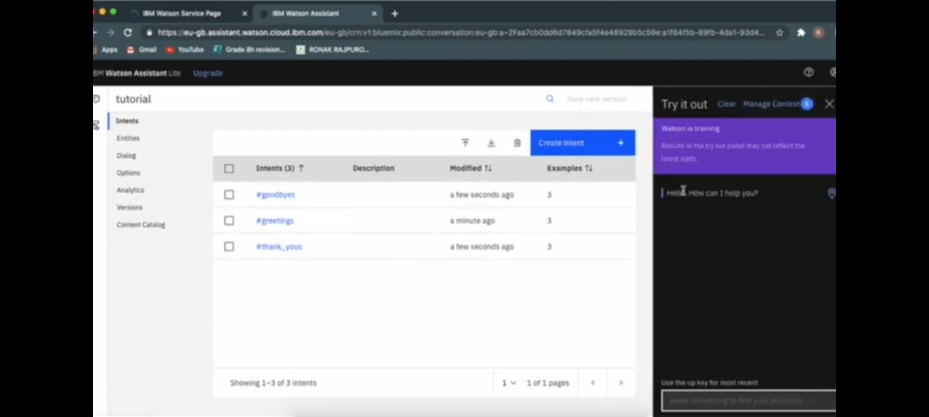

10.In the try it out window try the chatbot by greeting the chatbot as a user.

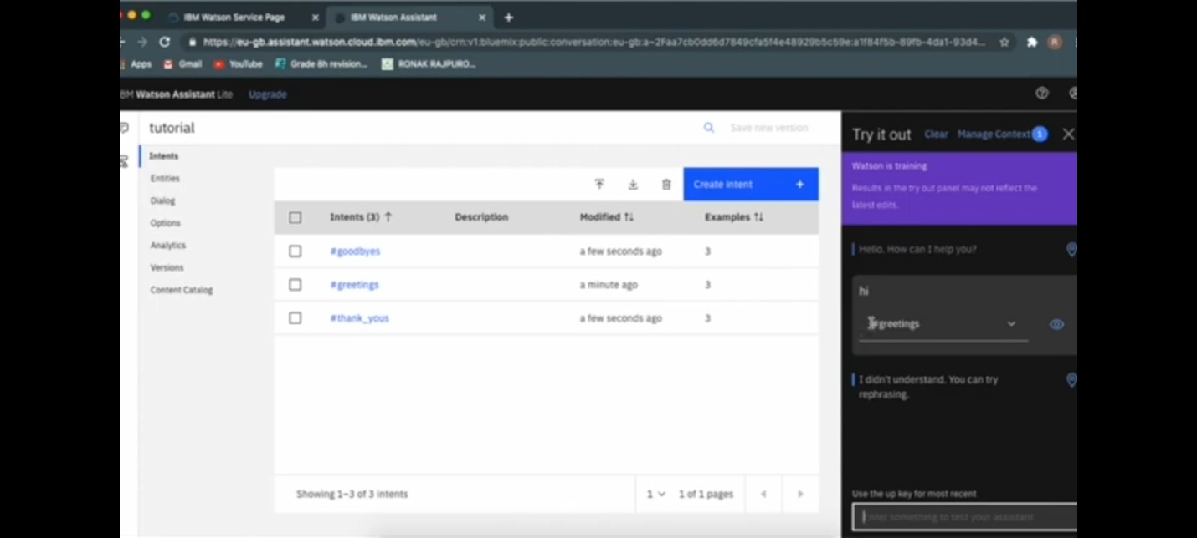

Group Members Name:

Swetha S

Kaviya J P

Kajoel P

Varsha A